Nebraska’s Clean Diesel Transit Bus Rebate program is offered by the Nebraska Department of Environmental Quality (NDEQ) to assist qualifying applicants to replace eligible older diesel transit buses with new buses powered by 2017 or newer model year compressed natural gas (CNG) engines certified to California Air Resources Board (CARB) Optional Low-NOx Standards (see below).
The following transit agencies in Nebraska operate buses eligible for funding under this program: StarTran (City of Lincoln) and Metro (City of Omaha). Each agency may apply for one rebate to replace one bus.

VEHICLES ELIGIBLE FOR REPLACEMENT
- Eligible vehicles are transit buses with diesel engines, model year 1995 through 2006, with Gross Vehicle Weight Rating of 14,001 pounds or greater (Class 4 to 8).
- Buses must be owned by a public transit agency in Nebraska, be currently in operation transporting passengers, and not otherwise planned for replacement prior to September 2021.

ELIGIBLE REPLACEMENT VEHICLES
Eligible replacement vehicles are new transit buses (2017 model year or later) powered by a compressed natural gas (CNG) engine certified to meet CARB’s Optional Low-NOx Standards of 0.1 g/bhp-hr, 0.05 g/bhp-hr, or 0.02 g/bhp-hr NOx.
The replacement bus must be in the same or higher weight class as the replaced bus and must be used to transport transit passengers.

REIMBURSEMENT
NDEQ will reimburse 35% of the cost of the new transit bus up to a maximum rebate of $175,000. The applicant is responsible for the remainder of the bus purchase price (cost-share).
Reimbursement will be made when NDEQ has received a reimbursement request with documentation that:
- The transit agency has paid for and received delivery of the new bus.
- The old bus has been scrapped in accordance with the program requirements (see below).

OTHER REQUIREMENTS
- No other federal grant funds may be used to cover any portion of the mandatory cost-share.
- One bid or quote for the replacement bus must be submitted with the application.
- The new bus may not be used to expand the applicant’s current fleet; the new bus must replace a bus that is currently operational and in use.
- The replaced bus and its diesel engine must be disabled (scrapped) within 90 days of replacement.
- Recipients must maintain ownership of the new bus for at least three years from the date of purchase. If the new bus is sold before the end of the three-year period, moved out of state, or used for purposes other than specified under this program, the rebate recipient must notify NDEQ and may be required to return up to the full amount of the rebate to NDEQ. The amount required to be returned is at the discretion of NDEQ, and will be determined on a case-by-case basis.
- Recipients will be required to file annual reports of mileage and fuel use for the duration of the agreement.

ADDITIONAL INFORMATION
Applicants selected for funding should complete their project by accepting delivery of the new bus and scrapping the replaced bus by August 30, 2019. Extension of a project beyond that deadline requires approval from NDEQ and the Environmental Protection Agency (EPA).

PROJECT AGREEMENT
- Rebate recipients must sign an agreement with NDEQ. The new bus cannot be purchased until the signed agreement is on file at NDEQ.
- After NDEQ has received the signed agreement, the recipient will be notified that they can complete the purchase of the new bus. Note: the date of the purchase order cannot pre-date the signature date of the agreement.

SCRAPPAGE
The old bus being replaced must be scrapped (permanently disabled) within 90 days of replacement and prior to submission of the reimbursement request to NDEQ. Scrappage consists of:
- Cutting, drilling, or punching a 3” by 3” hole completely through the engine block.
- Cutting completely through the chassis frame rails on either side between the front and rear axles.
Recipients should consult NDEQ in advance for approval of any other proposed scrappage methods.

APPLICATION MATERIALS CHECKLIST
Use the following checklist to ensure you’ve submitted all required materials with your application. A complete application will include all the documents listed below.
- Completed and signed application form.
- An organizational Dun and Bradstreet (D&B) Data Universal Number System (DUNS) number must be included on the rebate form.
- Completed IRS Form W-9, Request for Taxpayer Identification Number and Certification. Rebate recipients should consult their tax advisor concerning the tax implications of the rebate.
- Photocopy of the Nebraska vehicle registration for each bus being replaced.
- Photocopy of the title of each bus being replaced.
- Photograph of the bus (side profile) being replaced showing the vehicle unit identifying number.
- Photograph of the diesel engine emissions label showing the EPA Engine Family (see next page).
- Bid or price quote for the replacement bus, including estimated delivery dates.

SUBMITTING THE APPLICATION
Only signed and dated original applications received by mail, e-mail, or in person at the address below will be accepted. Rebate applications cannot be submitted by fax. The deadline for receiving applications is 5:00 pm on February 1, 2019. The department is not responsible for any applications that are delayed or lost in the mail. Applicants will receive an e-mail confirming NDEQ’s receipt of the application. It is the applicant’s responsibility to ensure that their application was received by the department by the respective deadline.

Mail, e-mail, or hand-deliver applications to:
Nebraska Clean Diesel Rebate Program
Nebraska Department of Environmental Quality
1200 N Street, Suite 400
Lincoln NE 68509-8922
NDEQ.AirQuality@nebraska.gov

Questions? Email us at NDEQ.AirQuality@nebraska.gov or phone 402-471-4272

DIESEL ENGINE EMISSIONS LABEL AND EPA ENGINE FAMILY:
NDEQ’s grant from EPA requires documentation of the engine model year of the vehicle(s) to be replaced. The EPA Engine Family is a 12 character (letters and numbers) identifier assigned when a diesel engine model is certified in compliance with EPA emission standards. The first character in the EPA Engine Family name is a code for the model year of the engine. Some examples of diesel engine emission labels showing the EPA Engine Family are shown below.

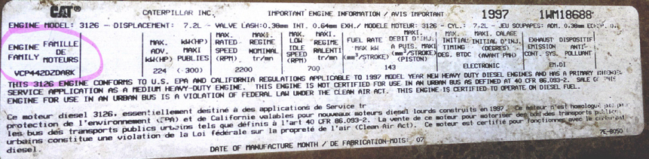

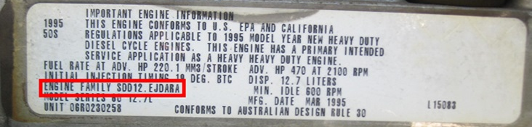

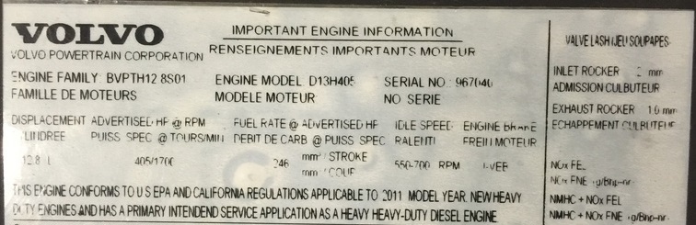

If the engine emissions label is missing or illegible, applicants should provide the engine serial number to the engine manufacturer to obtain written confirmation of the engine model year, and submit that manufacturer’s confirmation with their application.

This Page Intentionally
Left Blank
Section 1 – Applicant Information

Agency Name: ___________________________________________________________________________________
Project Manager (if different from authorized signatory): _________________________________________________
Address: ________________________________________________________________________________________
City State Zip Code
Email Address: __________________________________________________ Phone: __________________________
Tax ID Number: ________________________________________ DUNS Number: ____________________________

Section 2 – Original Bus Information
Vehicle ID Number (VIN)
Bus Unit Number
Vehicle make
Vehicle model
Vehicle year
Engine manufacturer
Engine model year (1995 to 2006 eligible)
Engine model
Engine EPA Family Name (see instructions pg. 3)
Engine horsepower
Gross Vehicle Weight Rating
Fuel Type
Annual Fuel Consumption
Annual Hours Idling
Annual miles traveled
Remaining years of service

Section 3 – Bid Information: Provide summary information from the dealer’s or manufacturer’s quote or bid in the columns. Please attach bid/quote to application.
Vendor: | Engine Manufacturer:
Bus Manufacturer: | Engine Model:
Bus Model: | Fuel:   CNG
Bus Gross Vehicle Weight: | Engine Horsepower:
Purchase Cost:
Other details:

Section 4 – Rebate Amount Requested Based on Bid/Quote
Base Purchase Cost of Bus: _______________________
Rebate amount requested*: _____________________ Applicant cost-share amount: ______________________
* 35% of the bus cost up to a maximum of $175,000.

Section 5 – Early Replacement Statement
The purpose of the Clean Diesel Program is to reduce emissions by the early replacement of polluting vehicles.
To meet EPA requirements, please provide a statement below certifying that the specified bus is not scheduled to be replaced before September 2020.

If your agency has a written bus replacement schedule or policy, attach a copy of it with your application.

What is the average length of time (years) your agency keeps a bus in service? ___________________________

Section 6 – Applicant Certification
Owner or Authorized Representative: I certify to the best of my knowledge that (check each item):
- The information contained herein is true and correct.
- The bus being replaced is currently in use, in proper working condition, and is used to transport public transit passengers. If selected for an award, the new bus will perform these same functions.
- The bus being replaced will be properly disposed of in accordance with the requirements of this agreement.
- The procedure for selecting the new bus followed public purchasing practices specified by my municipality.
- The new bus will not be used for fleet expansion.
- If selected for an award, the applicant will maintain ownership of the replacement bus for at least three years from the date of purchase. I understand that if the replacement bus is sold before the end of the three-year period or used for purposes other than specified in the conditions of this program, the applicant may be required to return up to the full amount of the rebate to NDEQ. The amount required to be returned is at the discretion of NDEQ, and will be determined on a case-by-case basis.
- I understand that I will not be eligible for any projects in which costs were incurred before the project period began and after the project period ends.
- I have the legal authority to sign this agreement.
- I acknowledge that failure to provide all applicable information and supporting documentation may result in the rejection of my application.

_____________________________________________________________________________________________
Printed Name and Title of Authorized Representative

_____________________________________________________________________________________________
Signature Date

